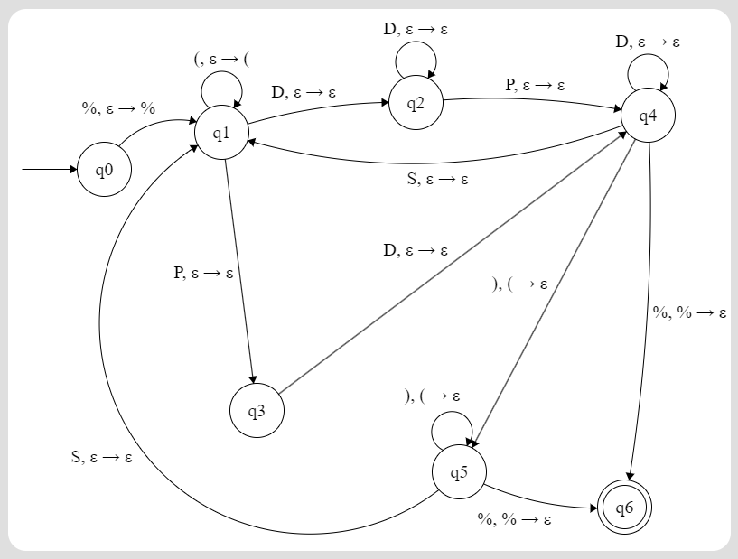

Above is attached the PDA Drawing for Project 2.

Where D = {0,1,2,3,4,5,6,7,8,9} set of all digits.
S = {*/+-} set of signs
P = {.} period

